Cloud DW Assignment
Name : Gopi Krishna Reddy Katkuri
1. Snowflake Assignment
Create Snowflake data warehouse yourusername_wh and use the existing database: snowbearair_db.promo_catalog_sales;

Run the following queries:

SELECT S_Name FROM SUPPLIER_AMERICA
WHERE S_ACCTBAL > 3000;
SELECT C_FirstName, C_LastName
FROM customer_america
WHERE C_FirstName LIKE 'S%';

SELECT c.c_firstname, c.c_lastname, o.o_orderdate
FROM customer_america c JOIN orders_america o ON c.C_CUSTKEY = o.o_custkey
WHERE C_FirstName LIKE 'S%' AND o.o_orderdate > '2015-01-01';

Submit
(1) Screenshots of query outputs and the total number of rows generated.
Query 1:
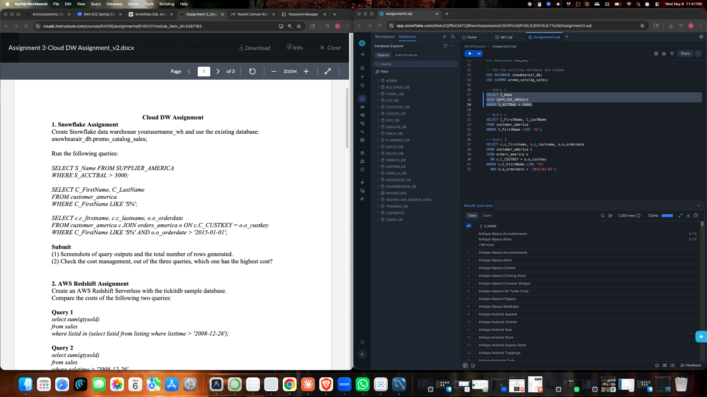

Query 2:
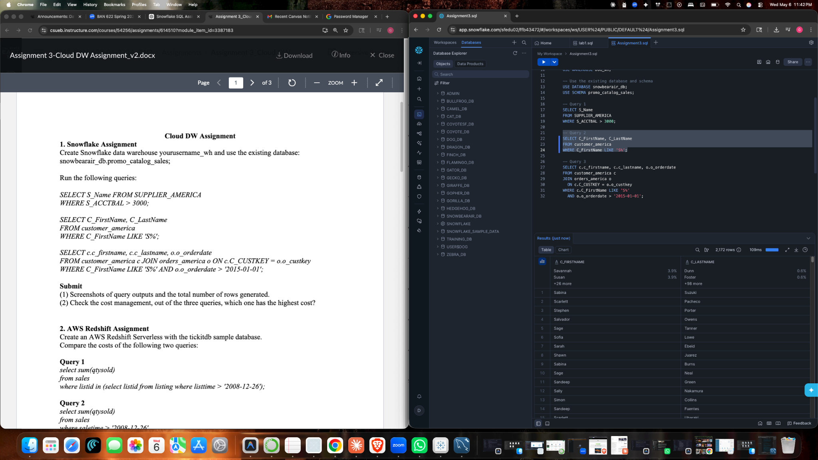

Query 3:

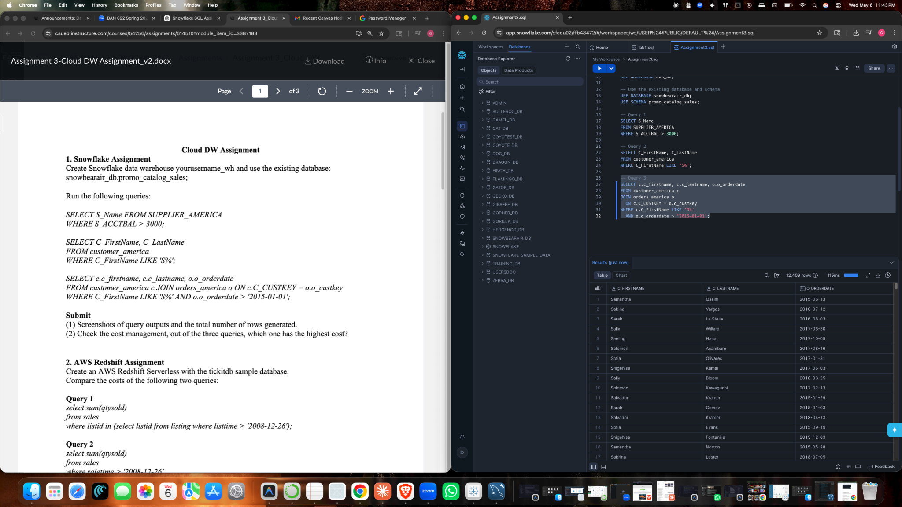

(2) Check the cost management, out of the three queries, which one has the highest cost?
ANS: Query 3 has the highest cost because it joins customer_america with order_america and returns the largest result set, 12,409 rows

2. AWS Redshift Assignment
Create an AWS Redshift Serverless with the tickitdb sample database.
Database tables created:

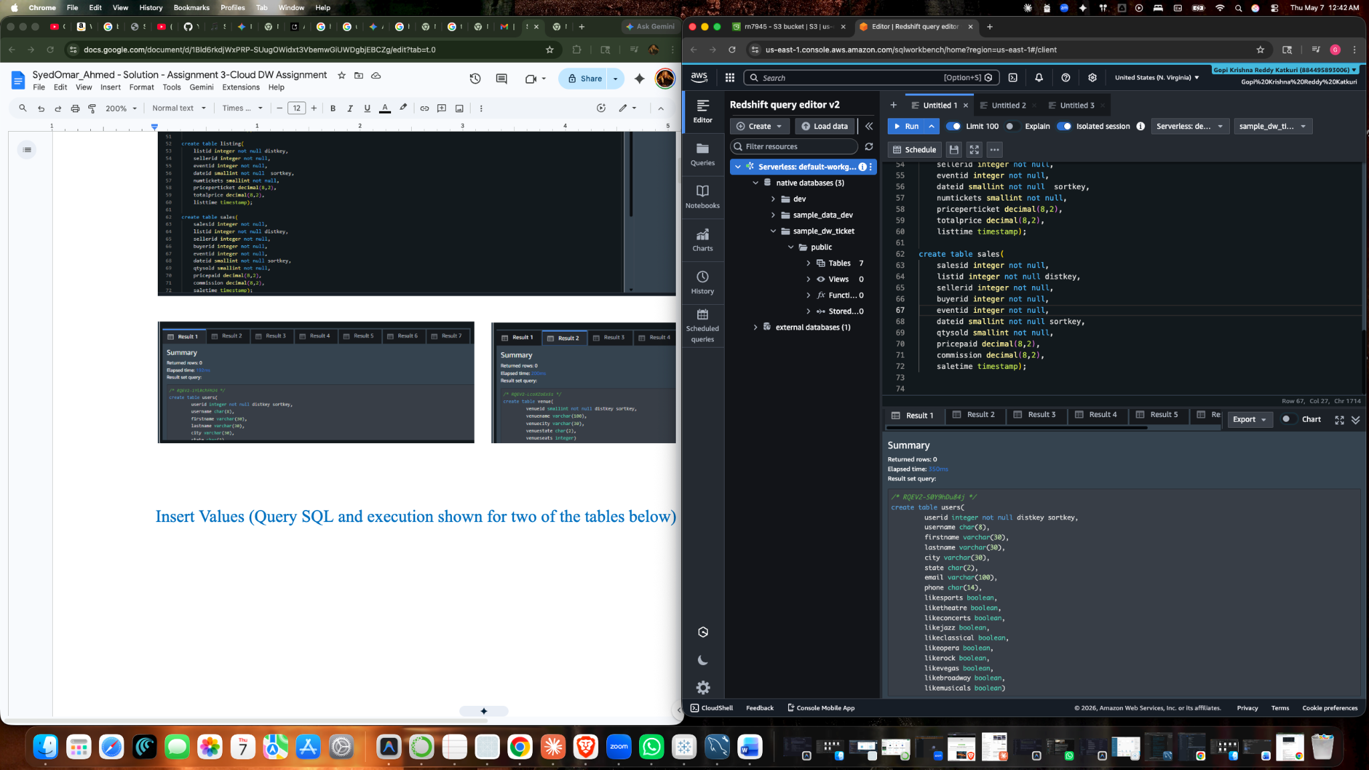

Sales tables:
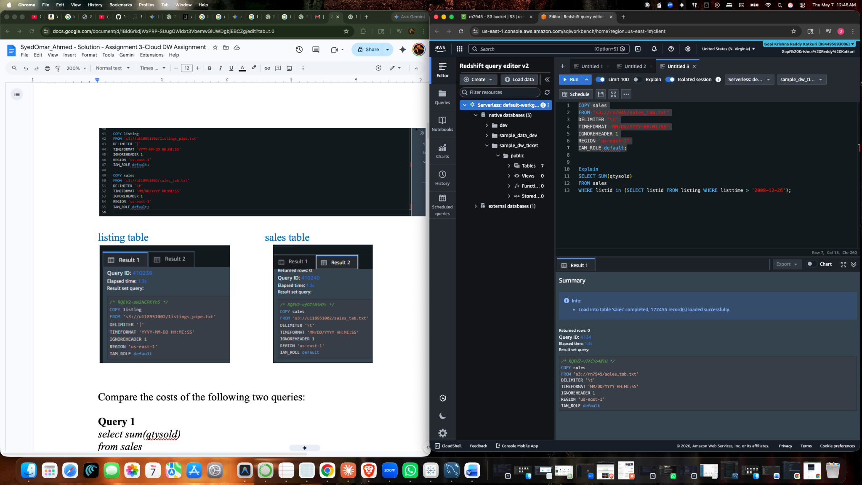

Listing table:
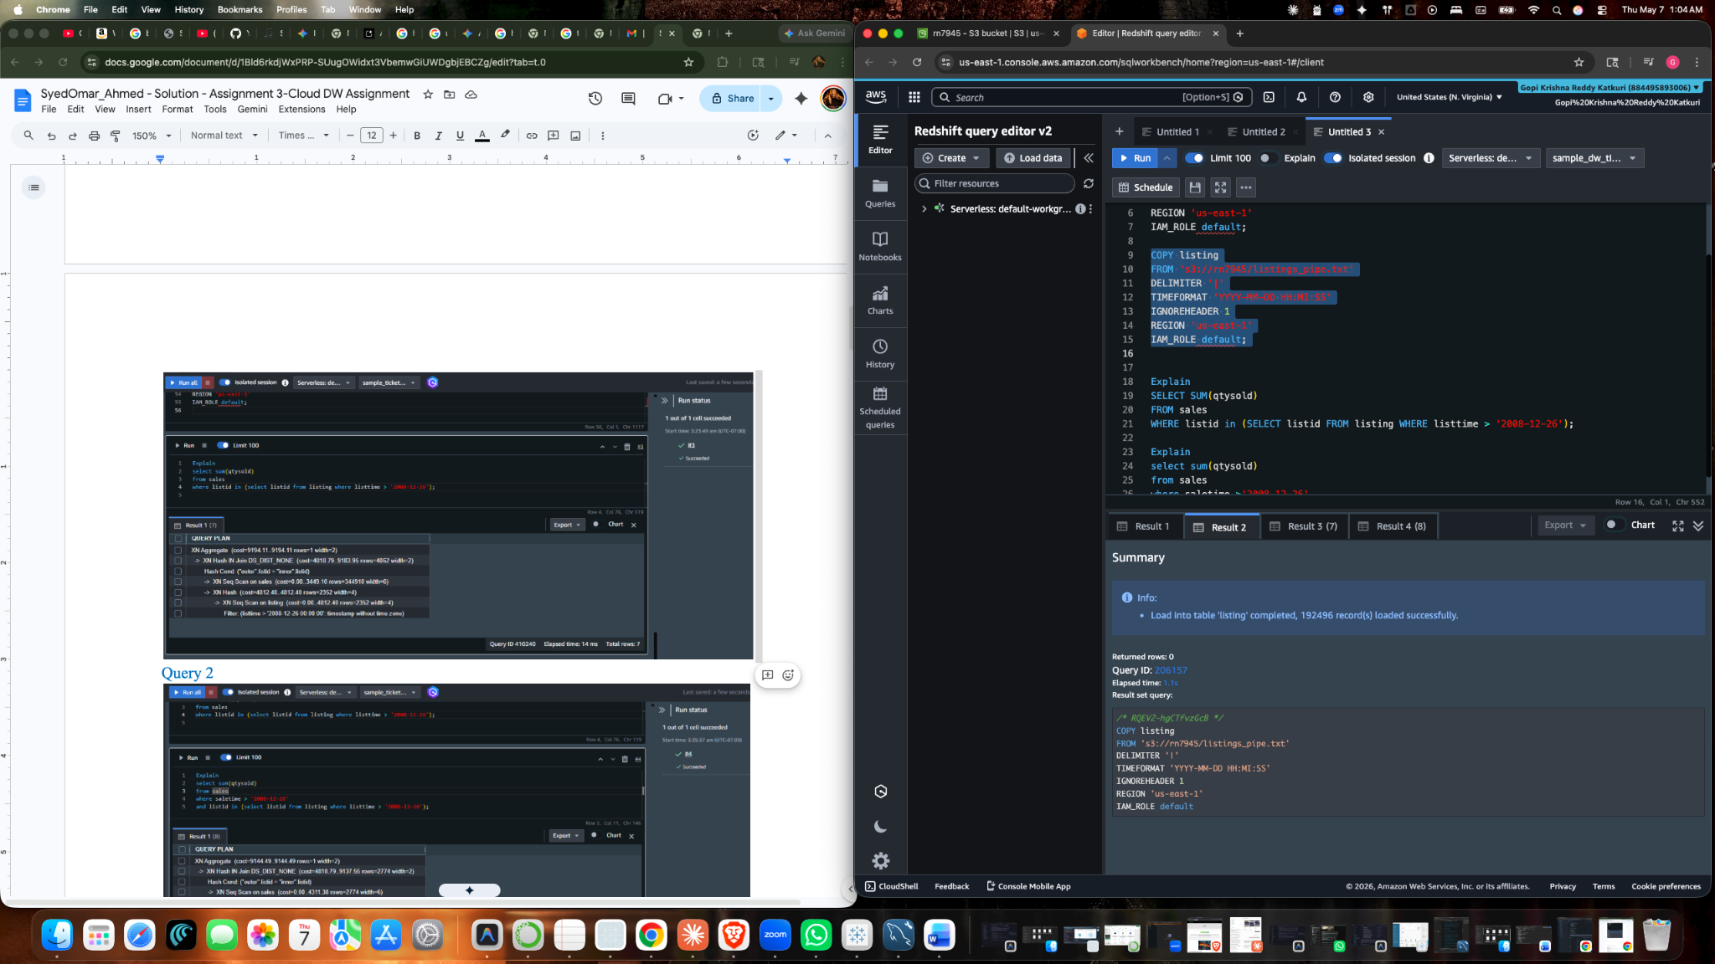

Compare the costs of the following two queries:

Query 1
select sum(qtysold)
from sales
where listid in (select listid from listing where listtime > '2008-12-26');

Query 2
select sum(qtysold)
from sales
where saletime > '2008-12-26'
and listid in (select listid from listing where listtime > '2008-12-26');

Submit
(1) Screenshot of queryplan for each of the two queries above.
Query Plans:

Query 1:
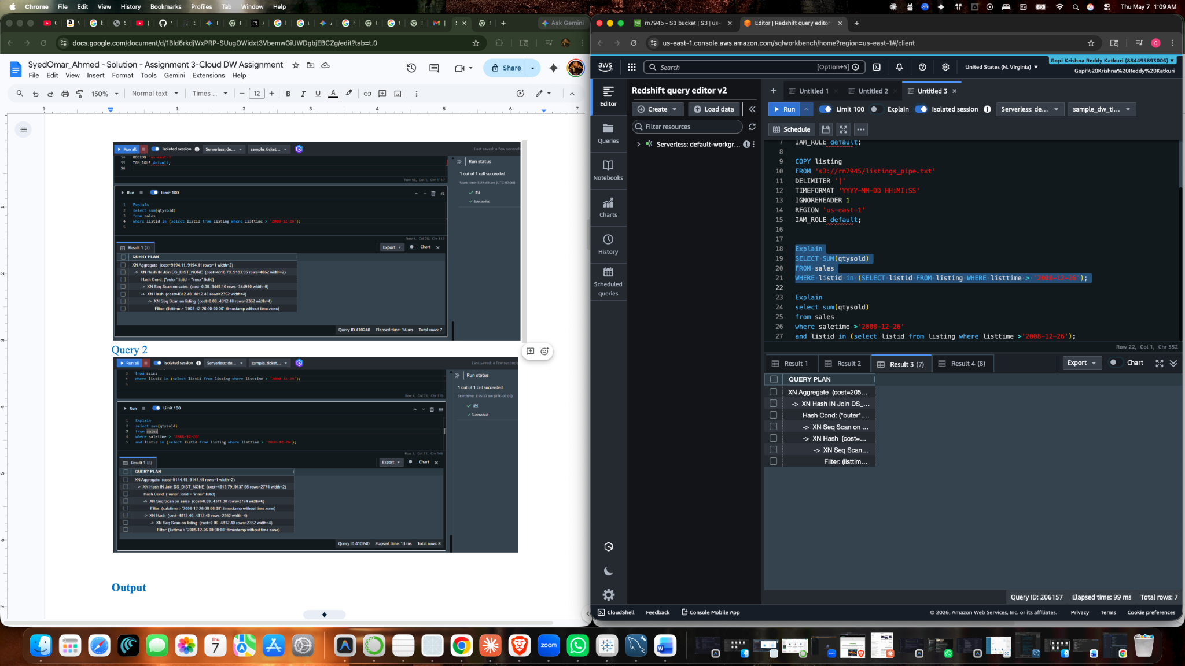

Query 2:

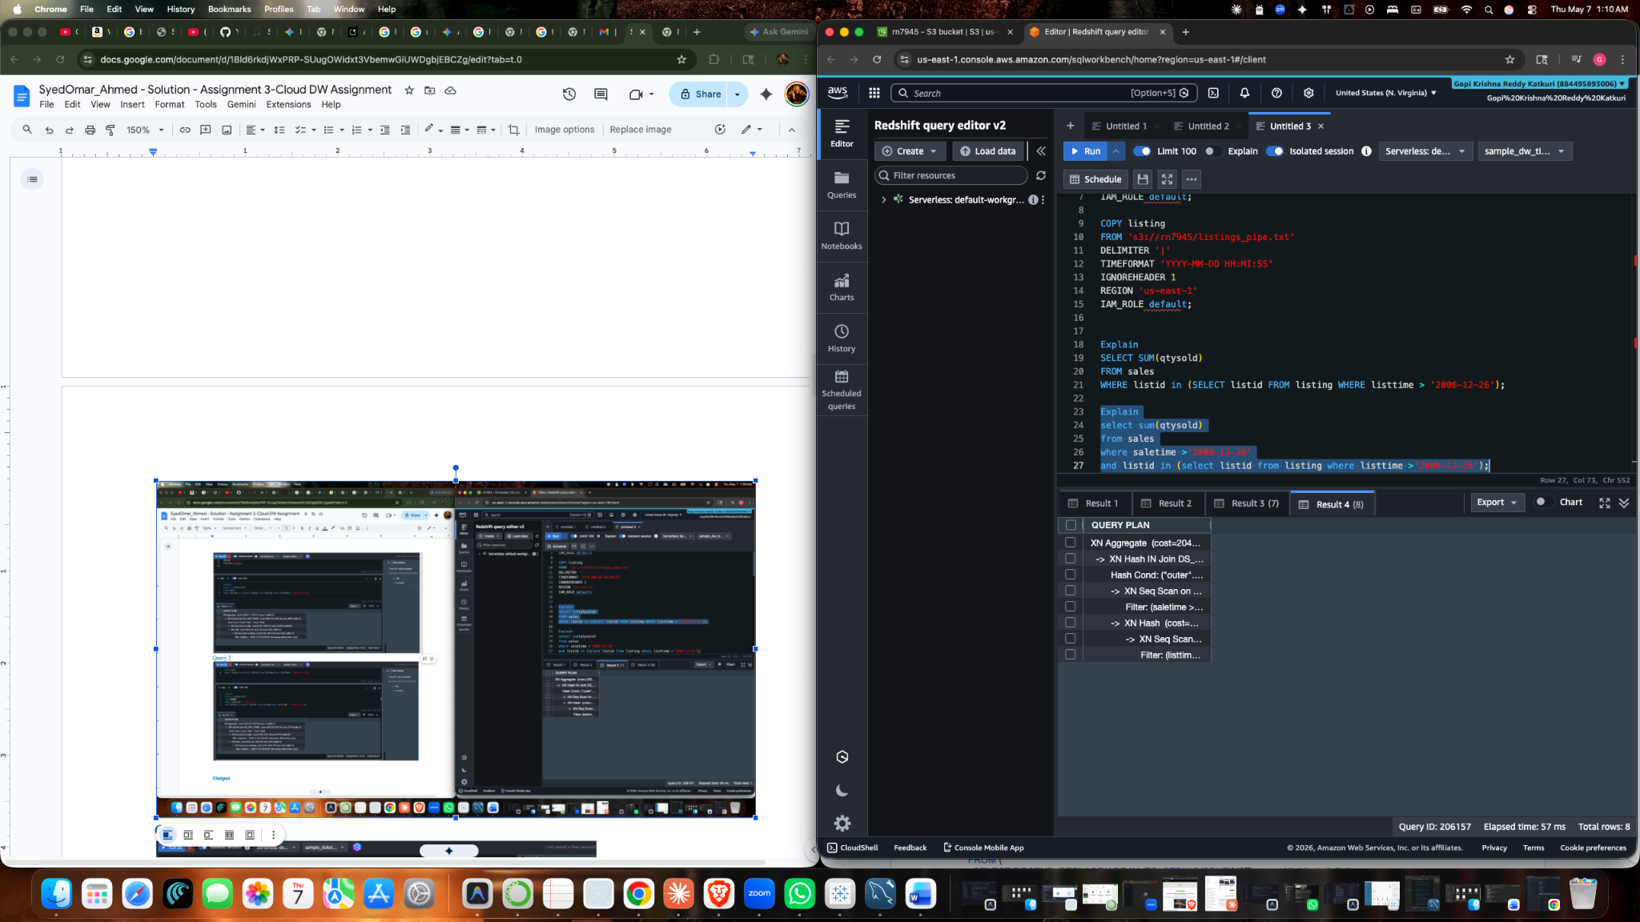

Results:
Query 1:

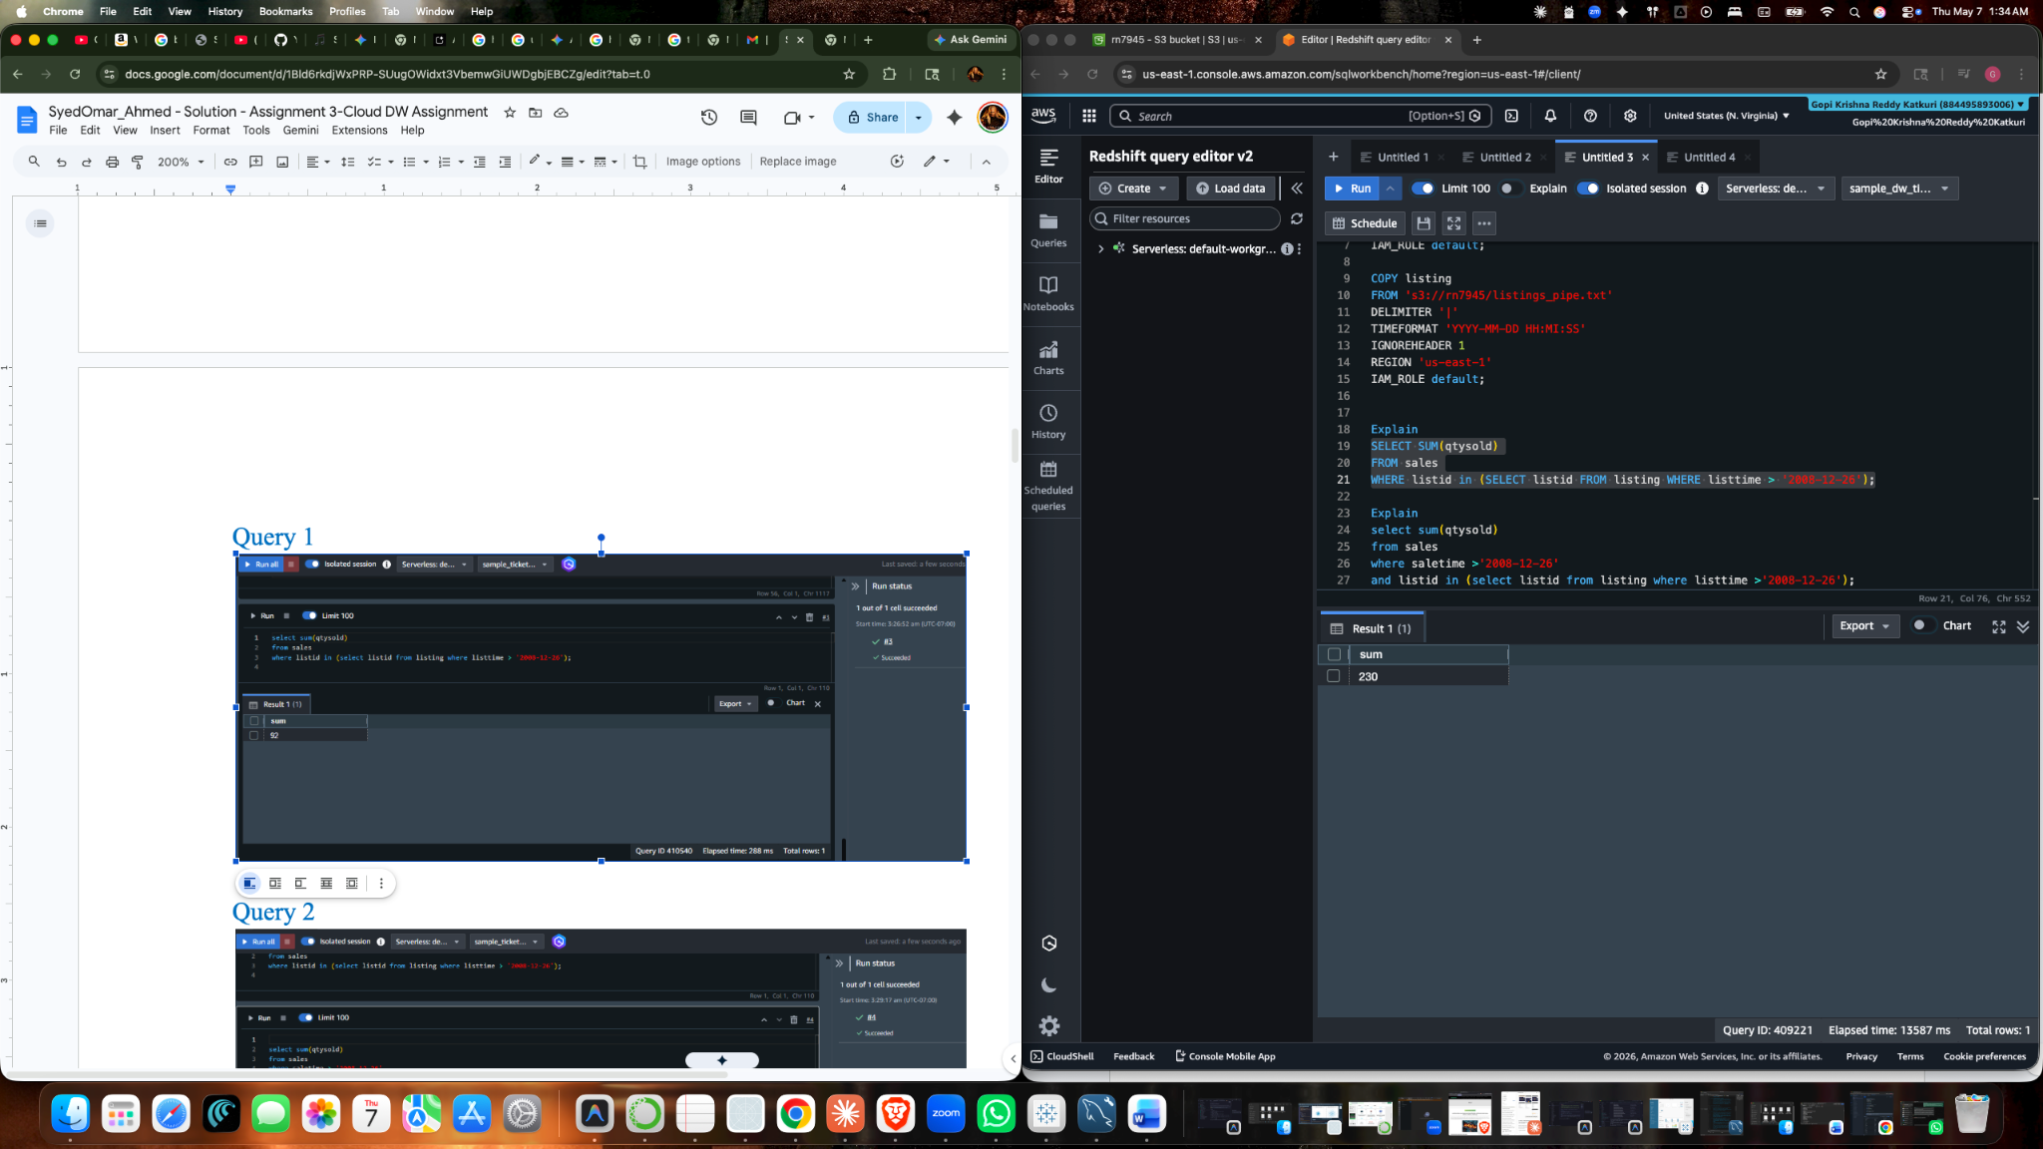

Query 2:

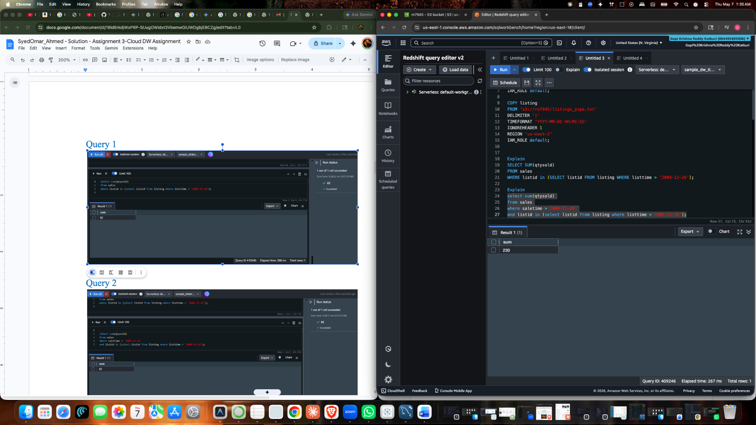
(2) A brief discussion comparing the two queries in terms of their expected output and query costs.
Ans: we can observe from above, the both queries produce the same output. The both queries don't have much difference in the cost but have difference in time taken to run query1 took 14 secs and query 2 took 884 milli secs.

Query 1:
Shows the total number of tickets sold for listings that were created after December 26, 2008. It does not matter when the actual sales took place.
Query 2:
Shows the total number of tickets sold only when both conditions are met: the listing was created after December 26, 2008, and the ticket was also sold after that date.

3. Google BigQuery
a. Load the sample data: GDELT, run the following query and calculate the execution cost:
Often you want to be able to run a query on the GKG and get back a list of the top people, organizations, general names, or themes that appear in matching coverage. For example, imagine creating a table of the top themes associated with Israeli Prime Minister Benjamin Netanyahu during his visit to the US Congress on March 3, 2015.
CAUTION: The query below may exhaust your monthly free limit on BigQuery! Optimize the query below to reduce query costs, and verify query costs before running the query.
SELECT theme, COUNT(*) as count
FROM (
SELECT REGEXP_REPLACE(ARRAY_TO_STRING(SPLIT(V2Themes, ';'), ' '), r',.*', '') theme
FROM `gdelt-bq.gdeltv2.gkg`
WHERE DATE > 20150302000000 AND DATE < 20150304000000 AND V2Persons LIKE '%Netanyahu%'
)
GROUP BY theme
ORDER BY 2 DESC
LIMIT 300

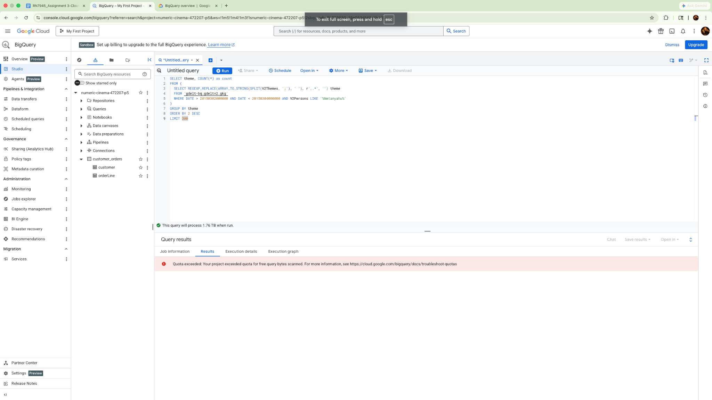
Optimized query and result :
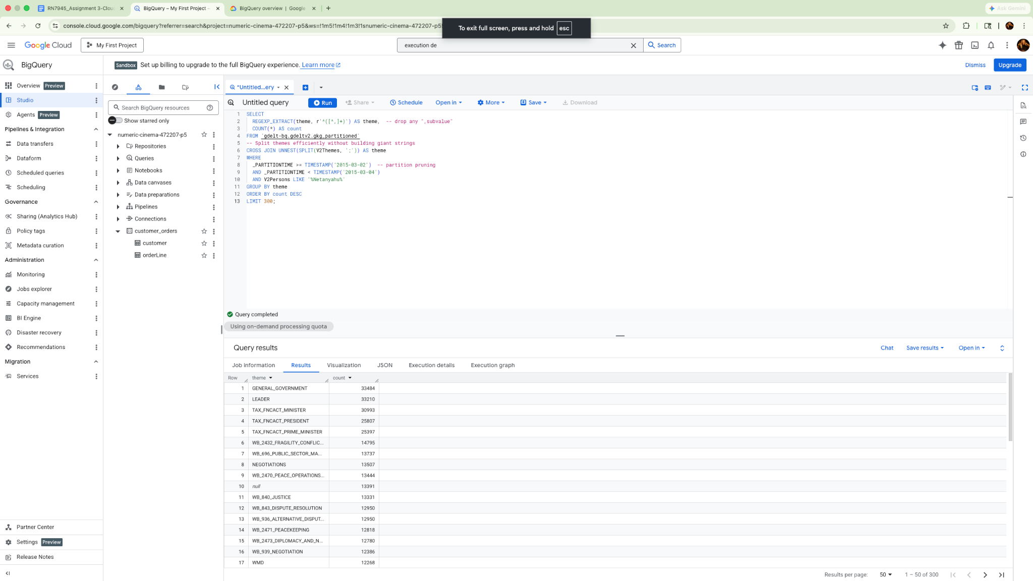
COST:
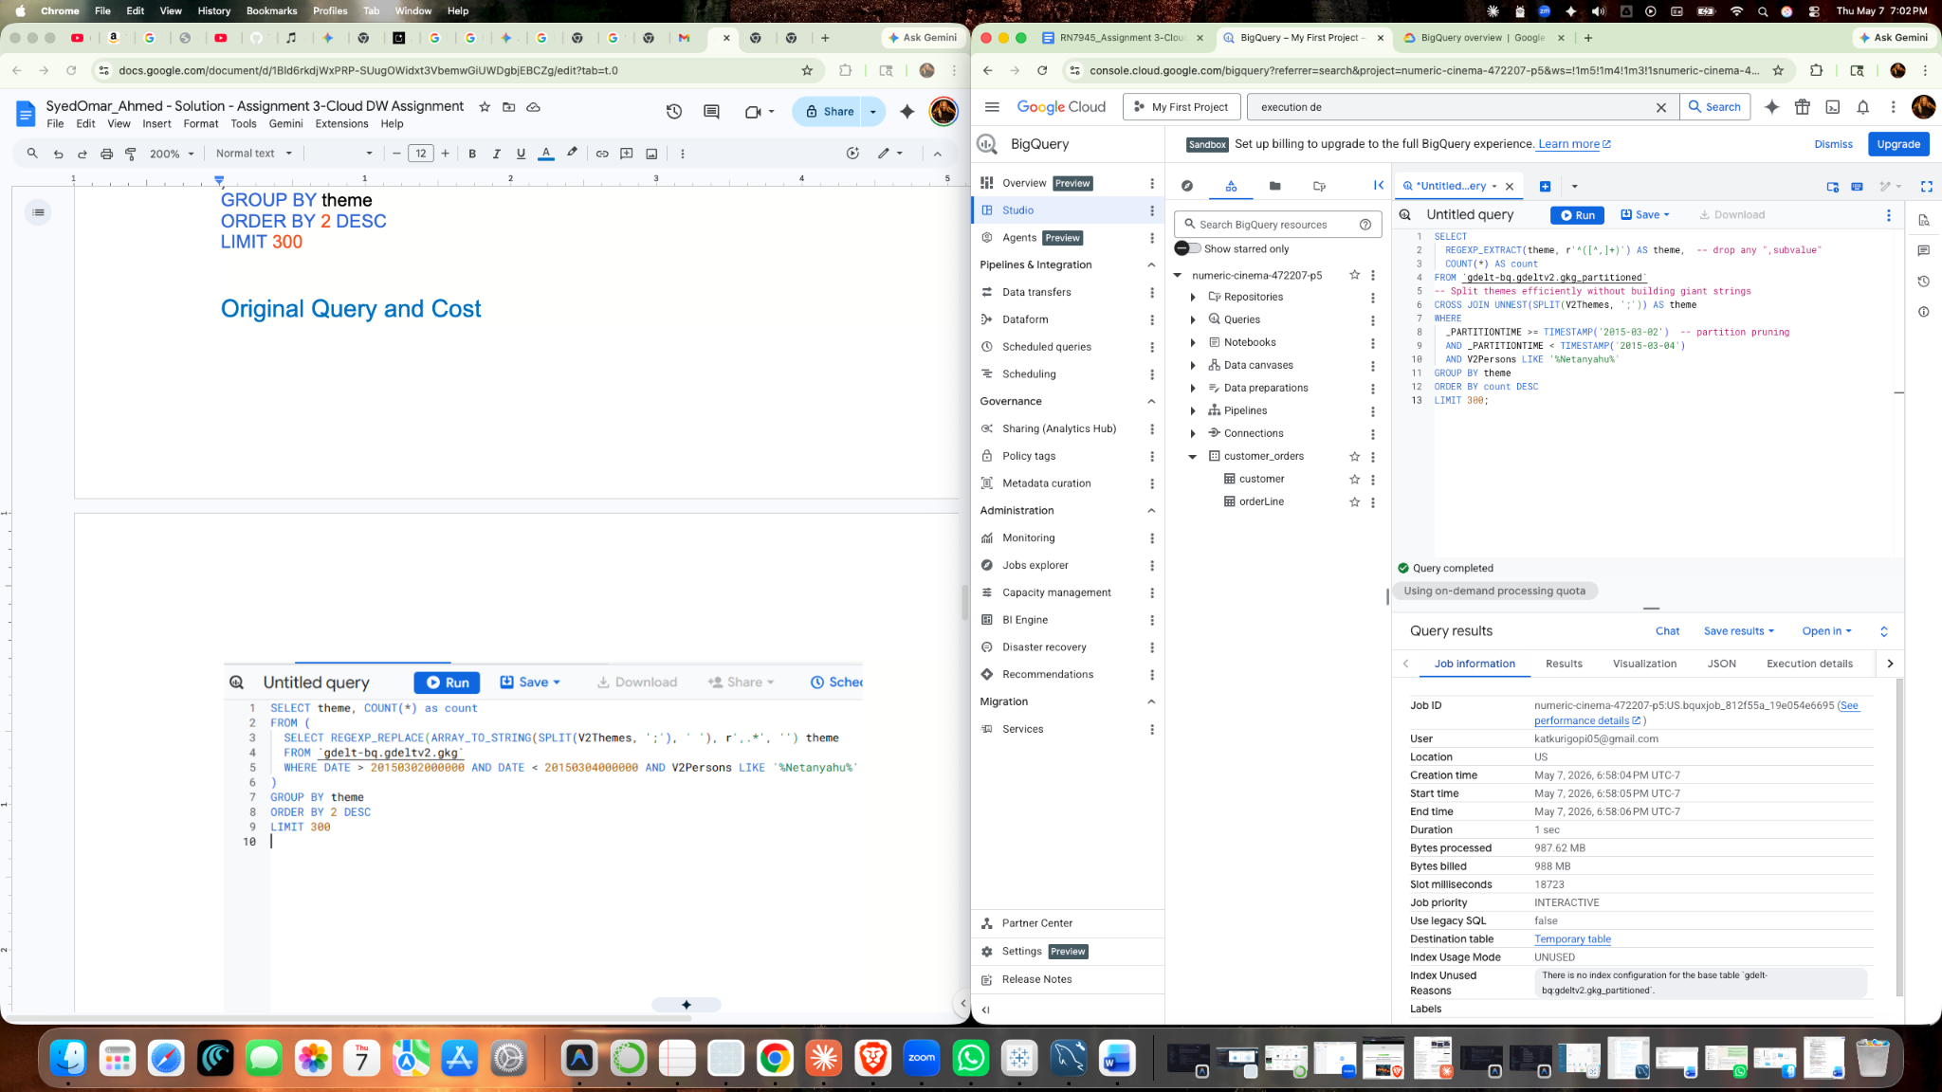
b. Examine a public dataset: natality
Examine the natality table schema in the samples dataset using bq show command, and Use the bq query command to run the following SQL query on data to extract How many children were born to mother's over 50 in the ten states with the most births:
SELECT
mother_age,
COUNT(mother_age) total
FROM
`bigquery-public-data.samples.natality`
WHERE
state IN (SELECT
state
FROM
(SELECT
state,
COUNT(state) total
FROM
`bigquery-public-data.samples.natality`
GROUP BY
state
ORDER BY
total DESC
LIMIT 20))
AND mother_age > 50
GROUP BY
mother_age
ORDER BY
mother_age DESC;

Submit:
(1). Screenshots of the query result and cost.
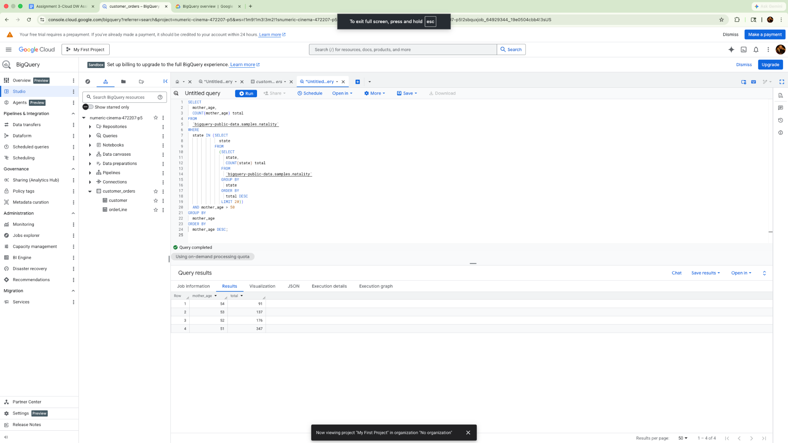
COST:
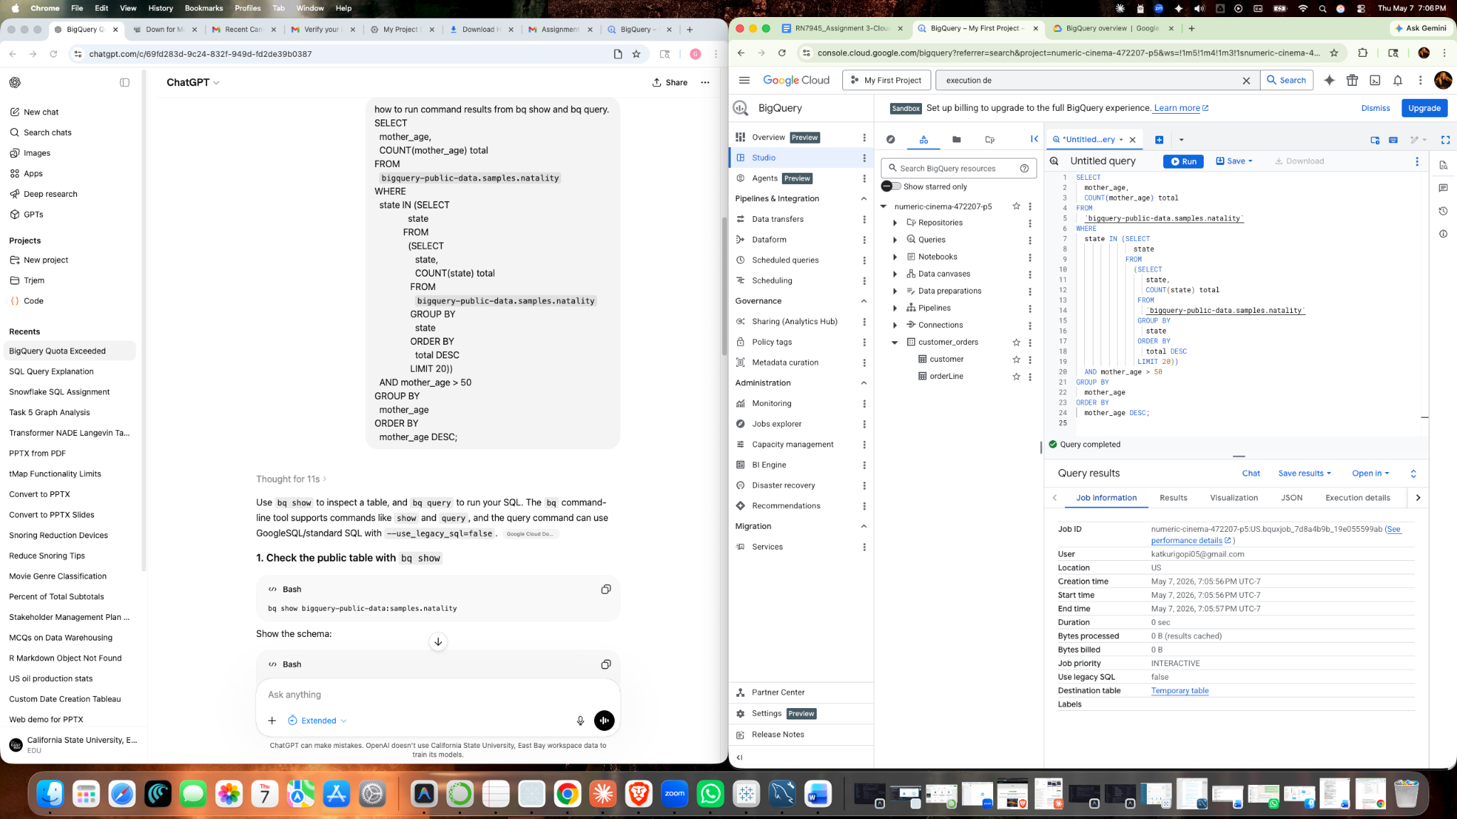
(2). Screenshots of command results from bq show and bq query.
Bq show command:
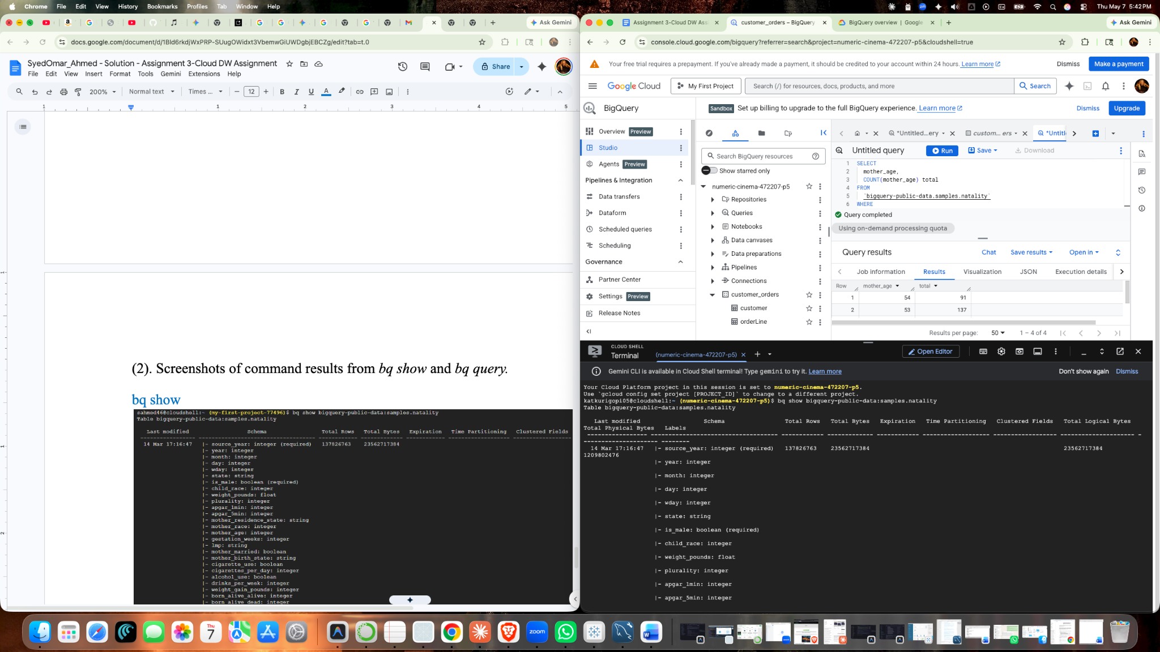

Bq query command:

